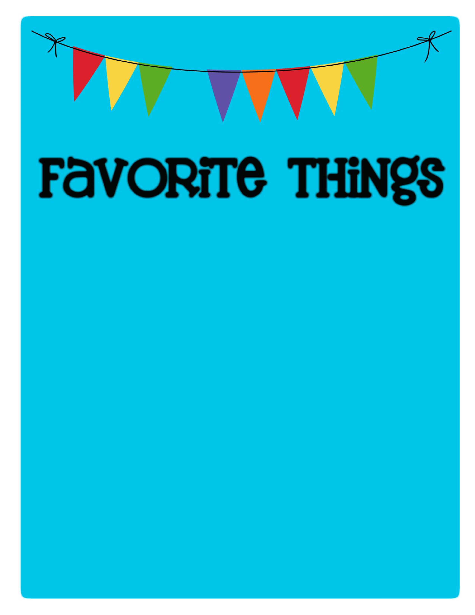

Name: Hannah King _________________________

Birthday: _July 20th

Favorites

Places to Eat: _Loving Hut, Any Thai Place, Shady Park Ramen

Places to Shop:

_ Buffalo Exchange, Rocket-A-Gogo

Favorite Gift Cards:_ Amazon, Sprouts, Black Rock, Kind Bean

Drinks :

Starbucks

:

Matcha Latte w/oat milk or cold brew w/hazelnut

Sonic

:

____________________________________

Other

:

_____Tea______________________________________

Scents (lotion, Scentsy, etc.): Bergamot, Floras (Jasmine, Sage, Lavendar

Candy/Snacks: Pistachios, spicy or savory, bbq chips, takis takis________________________________

Cookies/Cake: Chocolate Chips Cookies, Rice Krispies, Peanut butter

Flowers

:

____

Chrysanthemums, Sunflowers

Hobbies/Collectibles: __Conventions, Festivals, Yoga

Other Wish List Items: Cozy Blankets